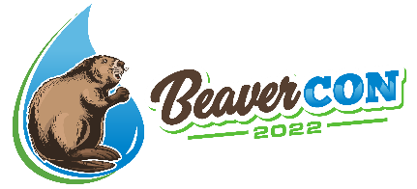

DAM GOOD Scholarship Application
To apply for a DAM GOOD Scholarship to attend BeaverCON 2022 in Hunt Valley, Maryland, March 8th - 10th, please fill out the following questions and send in your response to marketing@ecotoneinc.com.
Applications are due by February 8th.

Please note, this is a competitive scholarship for college students only and there are ten available. This unique opportunity was created to foster a diverse and welcoming environment for new ideas and to build a better future for environmental science where everyone is included. We ask for your patience as it will take time to process scholarship applications. All follow-up will be communicated via email.

Thank you for your interest in attending our conference. We wish you the best of luck!

Applicant Information

Are you applying for a one-day or three-day scholarship?
One-day |  | Three-Day

First and Last Name:

Email:

Phone Number:

Highest Level of Education Completed:

Please provide information on your current studies:
- Educational Institute:
- Major/Minor/ Concentration:
- Expected Graduation Year:
- Expected Degree (e.g. B.S. Environmental Science):

Where would you be travelling from?

How did you hear about BeaverCON?

Would you be willing to share your efforts, results, and unexpected lessons learned on the BeaverCON website and social media platforms so that others could benefit from your experience? Check your response below.

Yes
No

www.beavercon.org www.ecotoneinc.com

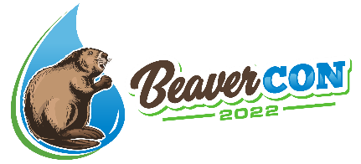

DAM GOOD Scholarship Application

Application Questions

- Tell us about yourself – where are you from, what are your hobbies and interests, etc.?

- What intrigued you about the BeaverCON 2020 conference and spurred you to apply for a scholarship?

- What role does ecological restoration and/or beaver management play in your life?

- What could you do within the next 1 to 3 years to help your community (neighbors, workplace, and school) understand the value of using beavers to create and foster healthy ecosystems that benefit your community and the larger world?

www.beavercon.org www.ecotoneinc.com

